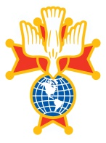

## Informational Brochure

**REACH YOUR HIGHEST POTENTIAL**

The Fourth Degree is a group of outstanding Knights, dedicated to promoting patriotism enlightened by their Catholic Faith. These Knights, distinguished by exemplary deeds for God, for country, and the Order, are united by the Fourth Degree to support religious, civic, and charitable causes.

Fourth Degree members belong to local units called Assemblies. Each Assembly is involved in a wide range of public patriotic activities.

Each Assembly maintains a Fourth Degree Color Corps and Honor Guard. These members participate in special civic and religious ceremonies.

For this reason, the Fourth Degree is often called the visible arm of the Knights of Columbus.

**ELIGIBILITY**

**To qualify for the Fourth Degree, one must:**

Be a Third Degree member in good standing in the Knights of Columbus.

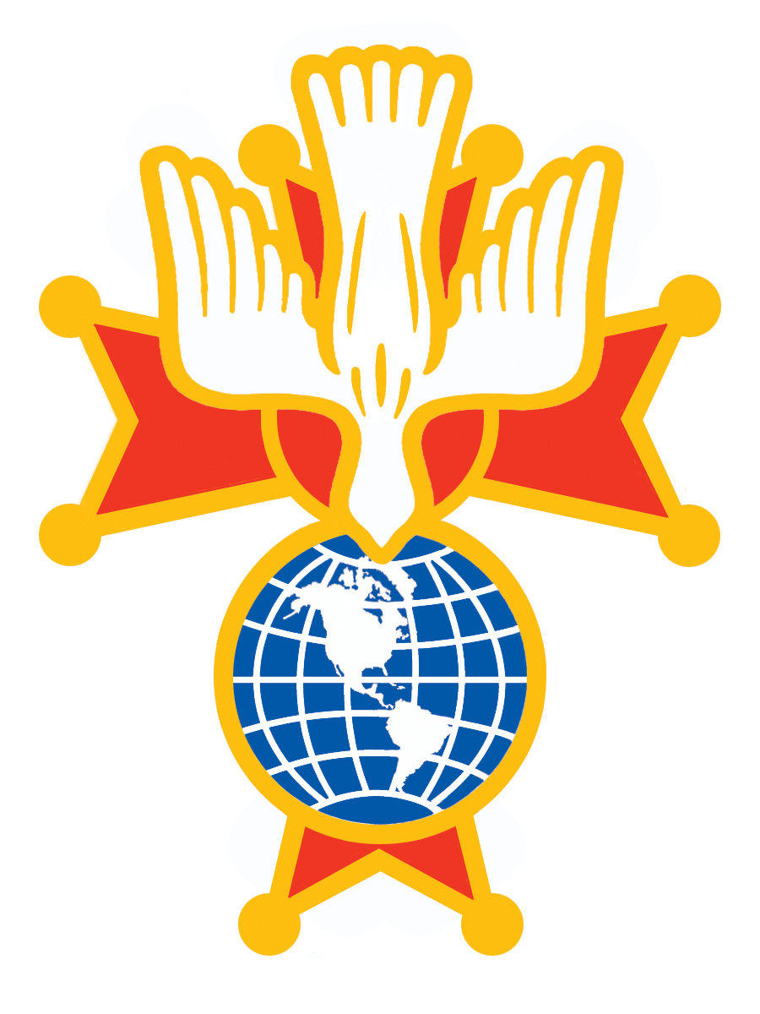

***EXEMPLIFICATION OF THE***

***FOURTH DEGREE***

KNIGHTS OF COLUMBUS

PENNSYLVANIA EAST DISTRICT

CALVERT PROVINCE



**Exemplification**

Saturday, November 9, 2019

**Honoree**

**TBA**

The Holiday Inn

(Harrisburg - Hershey)

604 Station Road

Grantville, PA. 17028

**Contacts:**

**Master**

S.K. Sean M. Connelly, Sr. 215-641-1120

[sconnelly29@verizon.net](mailto:sconnelly29@verizon.net)

**Administrative Assistant**

S.K. James P. McCarthy, FST 215-822-6369

[jamespmc07@gmail.com](mailto:jamespmc07@gmail.com)

**SCHEDULE OF FEES**

Initiation Fee (includes 1 banquet ticket, lapel pin, social baldric, and processing fees)

Lay Candidates, Deacons and Seminarian **$70.00**

Priests and members of religious order $**50.00**

Additional Banquet Tickets **$55.00**

Each candidate receives one banquet ticket, which is included in his fee. No credit is allowed if the candidate does not attend the banquet. **Tickets are not transferable.**

**Please submit your Candidate and Banquet form to your Assembly.**

**All Checks made payable to THE LOCAL ASSEMBLY YOU ARE JOINING!**

**DRESS**

The official dress for the Fourth Degree Exemplification is Dark suit, White Shirt (**No French Cuffs, no button down collars**), Neck Tie, Black Belt, Black Shoes. Religious wear their clerical garb and members of the armed forces or police and firefighting officers may wear their respective dress uniforms. Members shall wear the official dress plus the social baldric under the suit coat, **and only the** **PG-113 lapel pin,** plus their current jewel of office. ***If wearing the Fourth Degree uniform, a social baldric is not worn.***

**Notice**

All applications for membership in the Fourth Degree and banquet reservations must be made no later than **October 31, 2019**. Payment in full must accompany all banquet reservations.

**There will be a $5.00 late charge after October 31, 2019.**

**Admission to any of the events requires a pre-paid reservation prior to October 31, 2019. Walk-Ins will not be accepted.**

**Please submit your Candidate and Banquet form to your Financial Secretary, who will forward it on to your designated Assembly. There are no refunds of fees after the deadline of October 31, 2019.**

**EXEMPLIFICATION SCHEDULE**

Registration of Candidates 12:00 PM

Ladies Luncheon………………….. 12:30 PM

Exemplification 1:00 PM

Mass 4:00 PM

Banquet 7:30 PM

**Overnight Accommodations**

Rooms are available for Friday and Saturday nights by calling the hotel directly. The room rate is **$115.00** per night plus taxes. When making your reservation, please identify yourself as a **Knight of Columbus and use code KOC**.

Holiday Inn, Harrisburg - Hershey

604 Station Road

Grantville, Pa. 17028

717-469-0661 / 1-800-315-2621